Project Report

Ecommerce 8.8 Mega Sale Business Intelligence Analysis
Author: Lai Nguyen
Tools: SQL Server, Excel, Tableau Public, GitHub
Project Type: End-to-End Business Intelligence Portfolio

Table of Contents
- Executive Summary
- Business Scenario
- Business Objectives
- Database Design
- Business Metrics
- SQL Analysis
- Dashboard Overview
- Key Business Insights
- Business Recommendations
- Conclusion

1. Executive Summary

Project Overview
This project presents an end-to-end Business Intelligence solution developed to evaluate the performance of an e-commerce company's 8.8 Mega Sale campaign. The company sells consumer electronics through Shopee and TikTok Shop.
The objective was to measure campaign profitability, compare sales channels, evaluate promotional effectiveness, analyze livestream performance, and support data-driven business decisions.
The project covers the complete BI workflow:
- Database Design
- SQL Data Analysis
- KPI Development
- Interactive Tableau Dashboard
- Business Insights and Recommendations

2. Business Scenario
An e-commerce company launched a three-day 8.8 Mega Sale campaign across Shopee and TikTok Shop.
The campaign included:
- Flash Sale promotions
- Product discount vouchers
- Free gift promotions
- Livestream selling
- Shipping subsidies
Management wanted to evaluate:
- Was the campaign profitable?
- Which sales channel performed better?
- Which promotions generated the highest profit?
- Which products delivered the highest margins?
- Was the marketing investment worthwhile?

3. Business Objectives
The project aims to answer the following business questions:
- What was the overall profitability of the campaign?
- Which sales channel generated the highest ROI?
- Which promotion delivered the highest profit?
- Which products achieved the highest profit margin?
- What percentage of customers were new?
- How effective were livestream sessions?
- Which customers contributed the highest revenue?

4. Database Design

Database
Microsoft SQL Server

Database Name
Ecommerce

Database Structure
The database consists of relational tables representing a real-world e-commerce business.
Main entities include:
Table | Description
Customers | Customer information
Products | Product catalog
Categories | Product categories
Orders | Customer orders
OrderDetails | Individual order items
SalesChannels | Shopee and TikTok Shop
Promotions | Campaign promotions
Livestreams | Livestream sessions
Campaigns | Marketing campaigns
CampaignCosts | Marketing expenses

Database Diagram
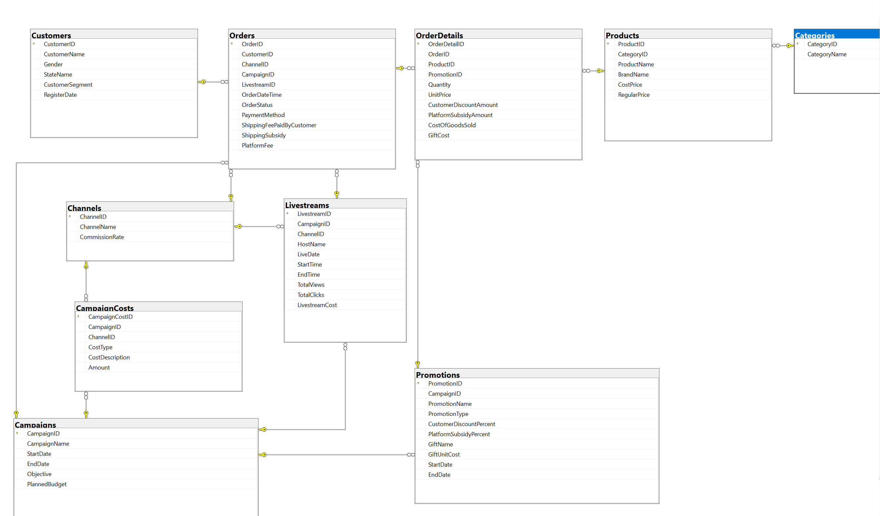

5. Business Metrics
KPI | Description | Formula
Revenue | Total sales before discounts | Σ Sales Amount
Net Revenue | Revenue after promotional discounts | Revenue − Discount
COGS | Cost of Goods Sold | Σ(Unit Cost × Quantity)
Platform Fee | Marketplace commission | Net Revenue × Commission Rate
Gift Cost | Cost of promotional gifts | Σ Gift Cost
Shipping Subsidy | Shipping cost paid by the company | Σ Shipping Subsidy
Profit Before Campaign Cost | Operating profit before marketing expenses | Net Revenue + Shipping Revenue − COGS − Platform Fee − Gift Cost − Shipping Subsidy
Total Campaign Cost | Total marketing investment | Direct Cost + Shared Cost + Livestream Cost
Net Campaign Profit | Final campaign profit | Profit Before Campaign Cost − Campaign Cost
ROI | Return on marketing investment | Net Campaign Profit ÷ Campaign Cost × 100
Profit Margin | Operating profitability | Profit Before Campaign Cost ÷ Net Revenue × 100
Promotion Profit | Profit generated by a promotion | Net Revenue − Related Costs
Promotion Profit Margin | Profitability of a promotion | Promotion Profit ÷ Net Revenue × 100
Product Profit Margin | Profitability of a product | Product Profit ÷ Net Revenue × 100
View-to-Order Conversion Rate | Livestream conversion | Orders ÷ Views × 100

6. SQL Analysis
The project includes analytical SQL queries to answer key business questions.

Query 1
Top 10 Best-Selling Products
Purpose
Identify products generating the highest sales volume.

Query 2
Revenue by Campaign Day
Purpose
Evaluate daily campaign performance.

Query 3
Shopee vs TikTok Shop
Purpose
Compare revenue, costs, profit, and ROI across sales channels.

Query 4
Promotion with Highest Revenue

Query 5
Promotion with Highest Profit

Query 6
Highest Livestream Conversion Rate

Query 7
Percentage of New Customers

Query 8
ROI by Sales Channel

Query 9
Top 20 Customers by Spending

Query 10
Profit Margin by Product

Query 11
Overall Campaign Performance

7. Dashboard Overview
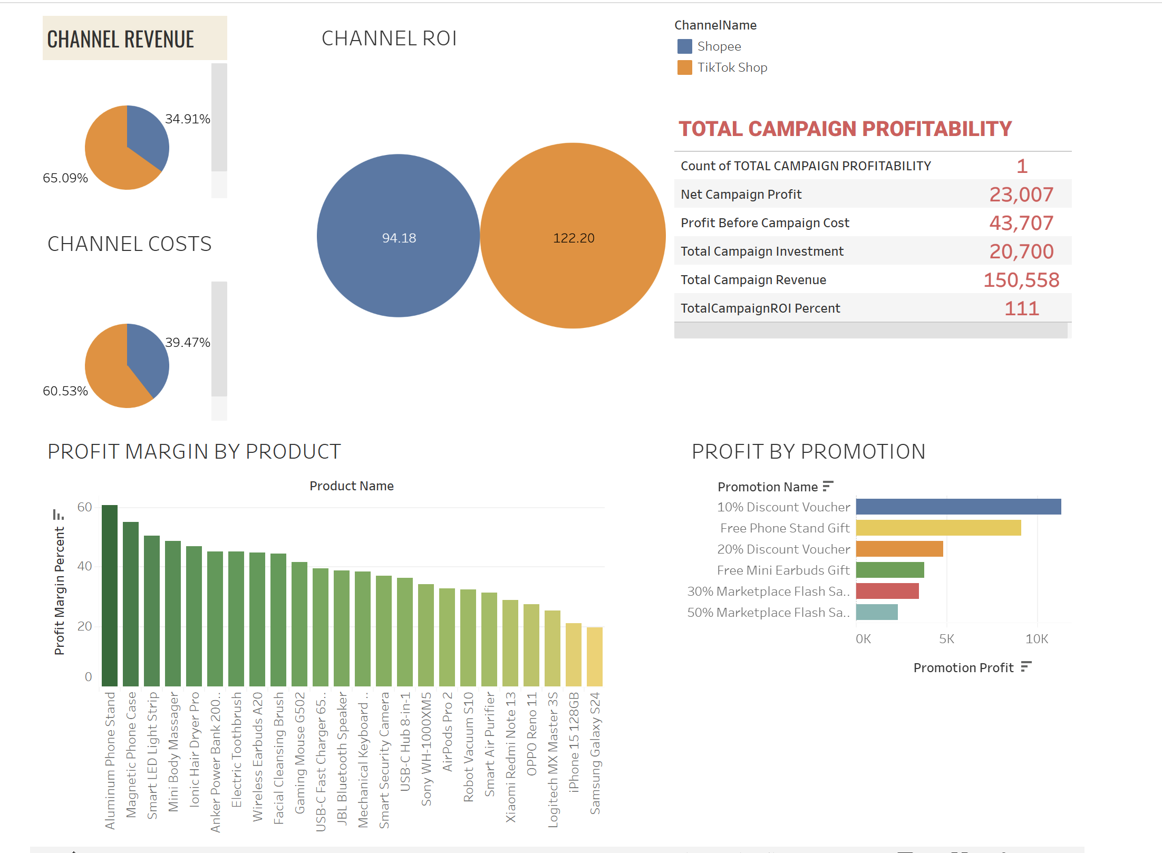
The Tableau dashboard provides an interactive overview of campaign performance.
Dashboard sections include:
- Revenue by Sales Channel
- Costs by Sales Channel
- Campaign Performance Summary
- Product Profit Margin
- Promotion Profit

8. Key Business Insights

Campaign Performance
The 8.8 Mega Sale generated $150,558 in net revenue and $23,007 in net campaign profit.
The campaign achieved an overall ROI of 111%, indicating that every $100 invested returned approximately $111 in net profit.

Sales Channels
TikTok Shop generated approximately 65% of campaign revenue while achieving the highest ROI.
Although TikTok required a larger share of campaign investment, its revenue contribution exceeded its share of costs, making it the most efficient sales channel.

Promotions
The 10% Discount Voucher generated the highest promotion profit.
Gift-based promotions also performed well, suggesting that value-added incentives can preserve profitability more effectively than deep price discounts.

Products
Product profit margins ranged from approximately 20% to over 60%, indicating significant variation in profitability across products.

Marketing Investment
The campaign remained profitable after accounting for all marketing expenses, demonstrating effective allocation of promotional resources.

9. Business Recommendations
Based on the analysis, the following recommendations are proposed:
- Increase future marketing investment in TikTok Shop due to its higher ROI.
- Continue using moderate discount vouchers to maximize profitability.
- Expand gift-based promotions for selected products.
- Prioritize high-margin products in future campaigns.
- Optimize livestream content to improve customer conversion.
- Continuously monitor campaign ROI to improve marketing efficiency.

10. Conclusion
This project demonstrates a complete Business Intelligence workflow, from relational database design and SQL analysis to interactive dashboard development and business storytelling.
The findings provide actionable insights into campaign profitability, channel performance, product profitability, and promotional effectiveness, enabling data-driven decision-making for future marketing campaigns.

